NAME:
My Family Career Tree

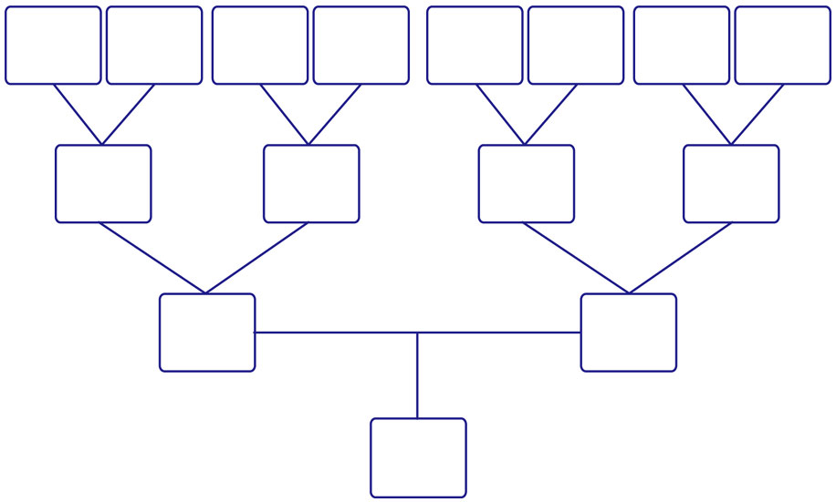
Great Grandfather
Great Grandmother
Great Grandfather
Great Grandmother
Great Grandfather
Great Grandmother
Great Grandfather
Great Grandmother
Grandfather
Grandmother
Grandfather
Grandmother
Dad
Mom
Me

